PRACTICAL-7

Assume, JK Enterprises hired a number of new employees to work in the Finance department. A new identity feed (service) will be created to load these new employees into IBM Security Identity Manager. To load new employees, a comma-separated value (CSV) file is used.

## **CSV Identity Feed Services**

This identity feed service type parses identity feeds with CSV file formats that comply with RFC 4180 grammar. The IBM Security Identity Manager parser has the following RFC enhancements:

Trims leading and trailing white space from unquoted text in a field. In contrast, RFC 4180 regards all space to be significant, whether inside or outside of quotation mark delimiters.

Allows quoted and unquoted text to be in the same field. In contrast, RFC 4180 does not allow both text types in the same field.

Does not enforce the RFC 4180 restriction that all records have the same number of fields. However, the code that calls the CSV parser reports an error if a record has more fields than the CSV header has.

Allows record termination to use carriage return (CR) or to use carriage return/line feed (CR/LF) to be compatible with both UNIX and DOS base files. In contrast, RFC 4180 terminates all records with carriage return/line feed (CR/LF).

CSV file format:

Uid,sn,cn,givenname,mail,initials,employeenumber,erroles

Tasks to be done:

* Creating a comma separated value (CSV) identity feed

1. First review the contents of newhires_finance.csv to confirm that the data looks correct.
   1. Open it in the Text Editor Icon from the desktop.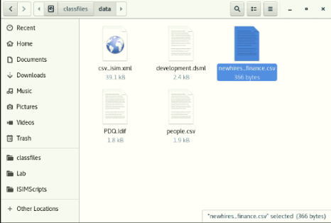
   2. Edit the file and Review it.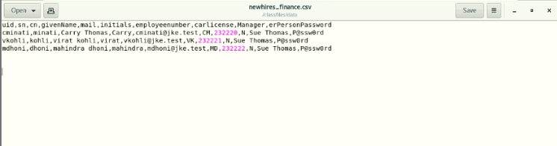
2. Log in to the IBM Security Identity Manager Administrative Console as the system administrator with the user ID itim manager.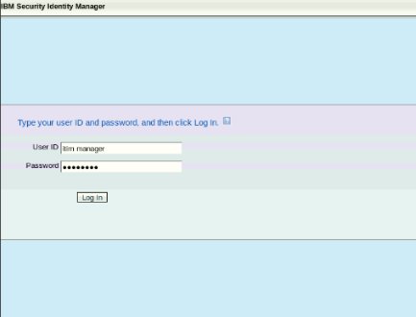
3. On the Home tab, navigate to Manage Services.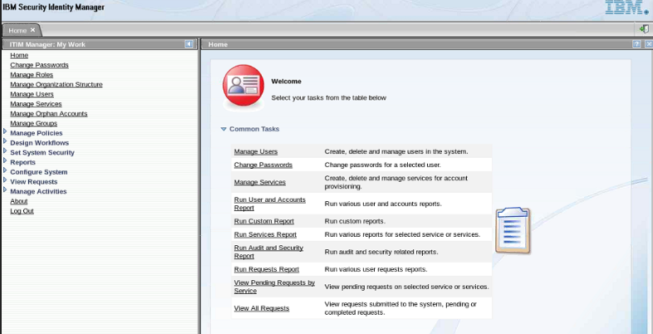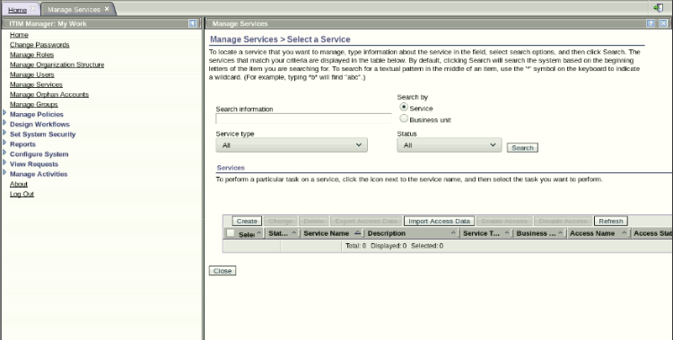
4. Click Create.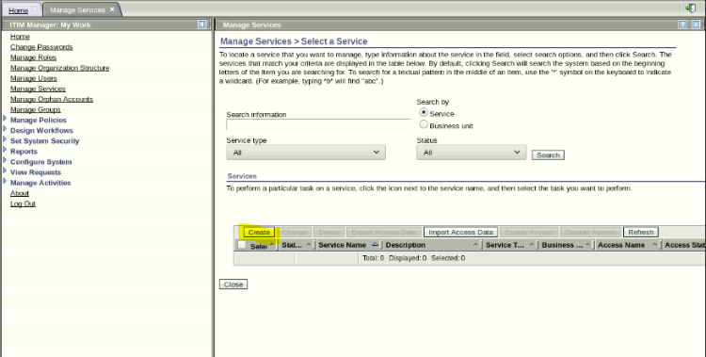
5. Confirm that the Finance53 business unit is selected or Click Search in front of Business Unit and Select Finance53.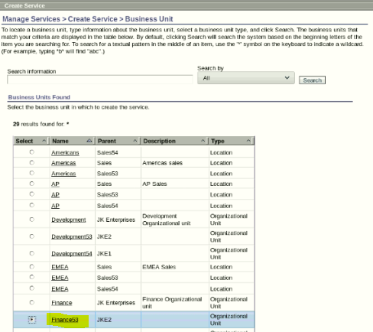
6. Select Comma Separated File (CSV) identity feed and click Next.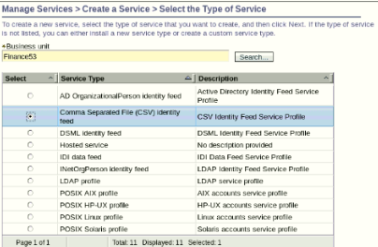
7. Complete the Create a Service form with the following information: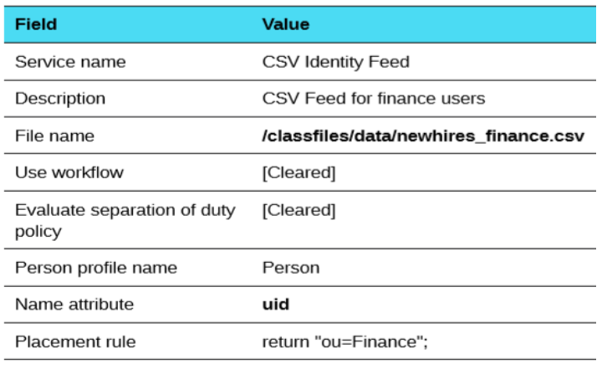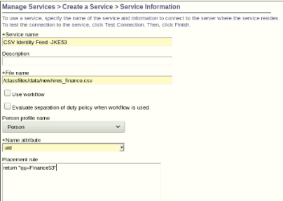
8. Click Test Connection. 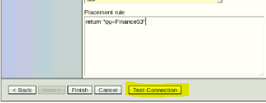
9. If the connection is successful, click Finish. If it is not, check that you entered the file name correctly.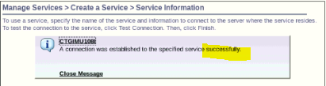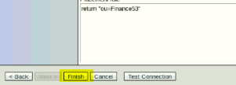
10. When you see the message that you successfully created the CSV Identity Feed, click close.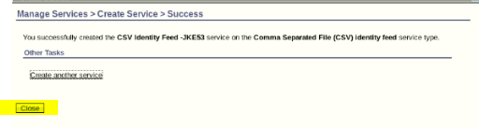
11. From Manage Services > Select a Service, click Refresh until the new service is shown in the list.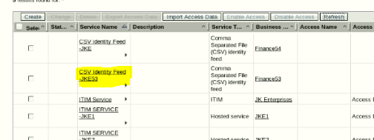
12. Click the small triangle to the right of CSV Identity Feed and click Reconcile Now. 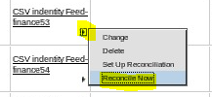
13. When you see the message that you successfully submitted a reconciliation request, click View my request. The reconciliation request should be the top-most request in the list.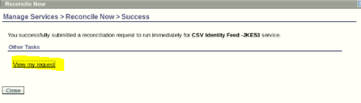
14. If the status of the request shows it is pending, click Refresh until it shows success. It might take several minutes to complete the reconciliation.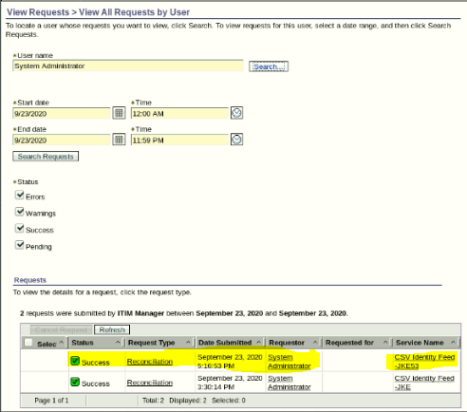
15. On the Home tab, go to the Manage Users area. Confirm that three new users are added to the Finance business unit.